About

**Interbeing**

It is utterly impossible to honour all people and non-human people who have made this website possible - there are dozens, hundreds, countless of them!

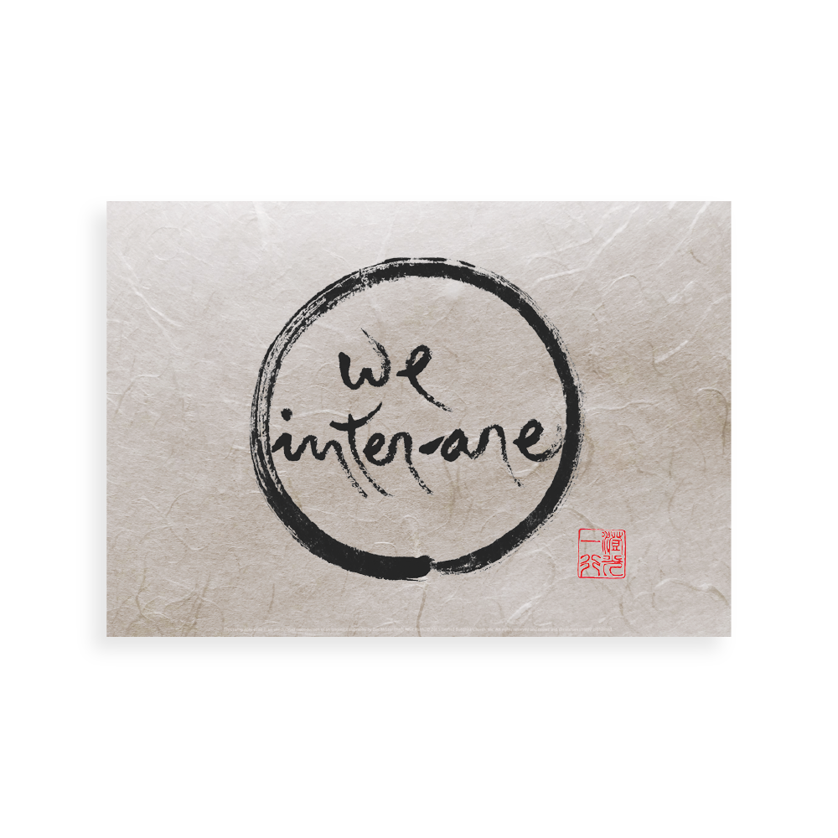­

[Source](https://plumvillage.shop/products/calligraphies-by-thich-nhat-hanh/english-calligraphies/we-inter-are-thich-nhat-hanhs-calligraphy/)

Who are these countless beings? Students learning with dedication and enthusiasm, Dharma friends supporting my practice, editors working on my textbooks along with their teachers and mentors, voice actors, artists, volunteers helping make videos, students translating the textbook into other languages, my family and society, dogs and cats appearing on the Zoom screen watering my seeds of joy, IT experts creating this platform, their mothers and ancestors, the farmer who grew the wheat which I enjoyed for breakfast, the clouds, the rain, the sunshine…

If we look deeply into the nature of རྟེན་ཅིང་འབྲེལ་བར་འབྱུང་བ། inter-being of everything, we’ll come to realize that ultimately the whole universe has come together to create this website to support your learning!

So, I’ll need to make a difficult choice and just mention *some* beings who have probably supported this website, my བོད་སྐད། Tibetan language activities and path of learning the most concretely.

With no further introduction, please join me to meet these cherished beings (and some of their quotes) who have accompanied and supported my work and continue to do so. It’s been and continues to be a journey of love, trust and dedication.

Going back in chronological order starting from today…

**Laurane Boulenger ལགས།**

This wonderful website has kindly been created with much love and skill by an alumna of our Tibetan Course and dear friend, Laurane Boulenger ལགས།. She also creates and designs amazing [French Courses](https://frenchwithoutdrama.com/) and [Tibetan language study materials](https://small-steps-tibetan.com/). But, what she loves the most are རི་བོང་། (bunnies).

**Tsering Gellek ལགས།**

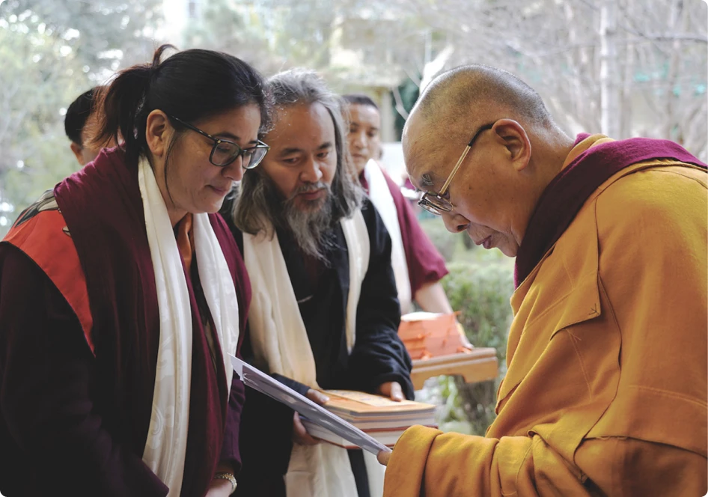

[Source of the image](https://www.sinibridge.org/)

Designing and offering all these innovative and engaging Tibetan language Courses and resources became possible thanks to the incredible and skilful support of Tsering Gellek ལགས།. She is the director of [SINI](https://www.sinibridge.org/), the Sarnath International Nyingma Institute. SINI’s motto is “Building Bridges of Goodness”. Countless such bridges have been and continue to be built by our dedicated students and committed colleagues at SINI all over the world. Tsering Gellek ལགས།’s skilful leadership, complete trust and deep love for our project is a guiding light for which I’m deeply grateful.

**Tarthang Tulku Rinpoche**

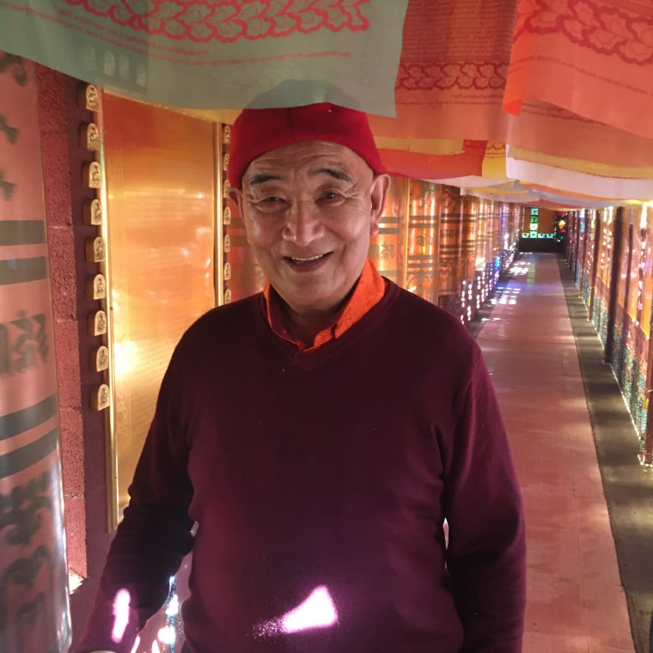

[Source of the image](https://www.sinibridge.org/about-sini/team-rinpoche/)

SINI would not exist if it wasn’t for Tsering Gellek ལགས།’s father, [Tarthang Tulku Rinpoche](https://www.sinibridge.org/about-sini/team-rinpoche/) asking her to build such an Institute. Upon hearing about Tarthang Tulku Rinpoche’s life-long, tireless commitment to the preservation of the Dharma, meeting Tsering Gellek ལགས། and some of his dedicated disciples in 2018, I decided to leave my job at UVa and join SINI instead. Tarthang Tulku Rinpoche with his incredible visionary mind and unceasing Dharma activities at the age of 90 is a true source of inspiration and I’m deeply humbled.

I love this quote of Rinpoche:

“If you want to do your best for future generations of humanity, for your friends and family, you must begin by taking good care of yourself.”

**Mr. Sloth ལགས།**

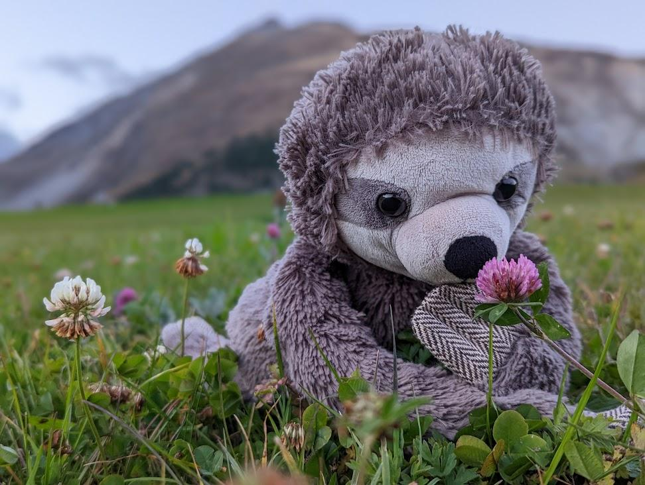

Designing and offering these Tibetan language Courses and resources, though being a very joyful activity is also a lot of hard work. Throughout these past years, Mr. Sloth ལགས།, one of our non-human students, has taught us many beautiful lessons, especially the one that resting is an art and is important. Mr. Sloth ལགས། (aka. དོམ་བུ་ལག་རིང་ལགས། lit. “bear with long arms”) is my mascot, the favorite protagonist of our videos and an inspiration for our dedicated students and colleagues. He exemplifies qualities such as being slow, relaxed, peaceful, humorous and yet engaged and interested. His version of the Nike slogan is: “Just do it - tomorrow!” :-)

**David Germano ལགས།**

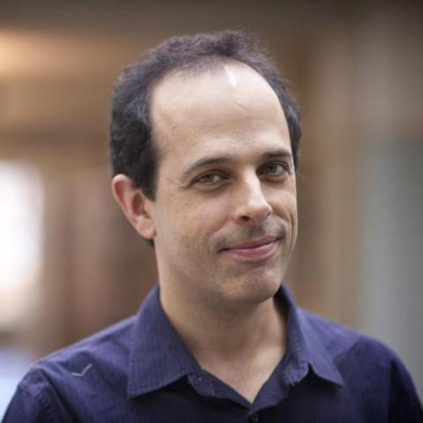

[Source of the image](https://religiousstudies.as.virginia.edu/david-germano)

During my time at UVa, the University of Virginia, I received a lot of support and guidance from David Germano ལགས།, for which I’m grateful too. The dinners at his house with interesting people from the world of academia were always interesting and fruitful. Although, I do need to admit that the best part of it always was his wonderful, big dog Snowy. :-)

**Geshe Wangdrak ལགས།**

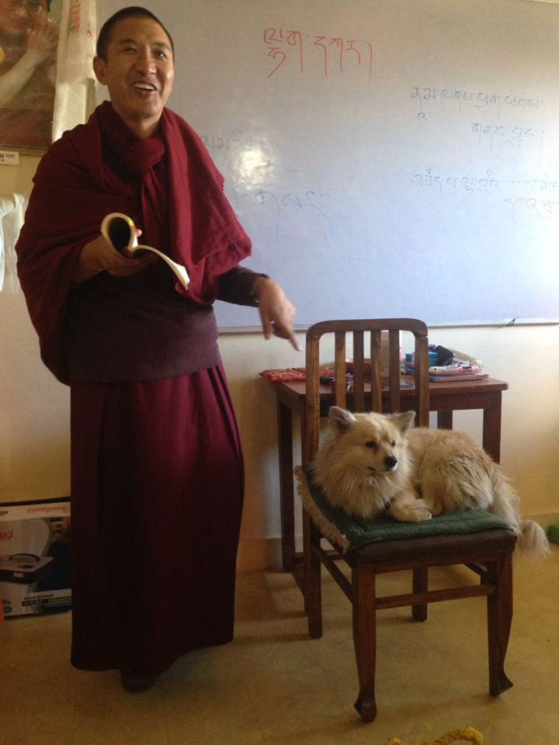

I’ve always had and continue to have the honour and privilege to work with wonderful Tibetan colleagues. The one I learned the most with and from was Geshe Wangdrak ལགས། at the LRZTP program in Dharamshala, 2015-2017. Geshe ལགས། was an extraordinarily kind, skilful, open-minded and humorous teacher and colleague. May we keep alive what we have learned from Geshe ལགས། and thereby be his beautiful continuation! Geshe ལགས། made his transition in 2025 and is missed and remembered dearly.

**རྒན་ Christabella ལགས།**



During my time teaching at the [LRZTP](https://www.lrztp.org/) program in Dharamshala, we had two doggies joining our classes. To me, their presence was enriching because I love animals. I believe that there are many beautiful and profound lessons we can learn from them, such as the art of showing joy, being resilient, loyal, etc. རྒན་ Christabella and རྒན་སེང་གེ་ལགས། (Professor Lion) thus became the protagonists of my textbook, illustrating the synthesis of indigenous grammar and contemporary learning methodology.

**རྒན་ Mingyur ལགས།**

Speaking of *The Heart of Tibetan Language* textbook…

My big fascination and little knowledge about the indigenous Tibetan grammar, I owe it all to my fantastic private Tibetan language teacher རྒན་མི་འགྱུར་ལགས།. In countless hours of classes, he skilfully revealed to me the oral teachings on the profound Colloquial Tibetan language and grammar, which is hardly written down. If it was not for him, my textbook series *བོད་སྐད་སྙིང་པོ། Heart of Tibetan Language*, would simply not exist. Everything I wrote in my [MA thesis](https://drive.google.com/file/d/1TERVlXr74gGK9PYTe9kOlcyCUdpxz0N9/view?usp=sharing), I’ve also learned from him. My gratitude to him is very deep.

**Tokpa Tulku ལགས།**

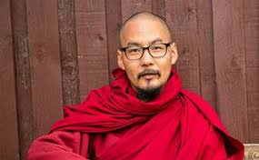

[Source of the image](https://buddhanature.tsadra.org/index.php/People/Tokpa_Tulku)

Another wonderful teacher who needs to be mentioned is Tokpa Tulku from [RYI](https://ryi.org/), Rangjung Yeshe Institute. Not only was he my favorite རྒན་ལགས། (teacher) during my MA studies, teaching us རྒྱུད་བླ་མ།, the *Mahāyānottaratantra Śāstra*; in his free time, he sat with me for hours and hours to carefully compose the wonderful Dharma dialogues of Volumes 3 and 4 of my textbook.

**My བོད་པའི་ནང་མི། Tibetan family**

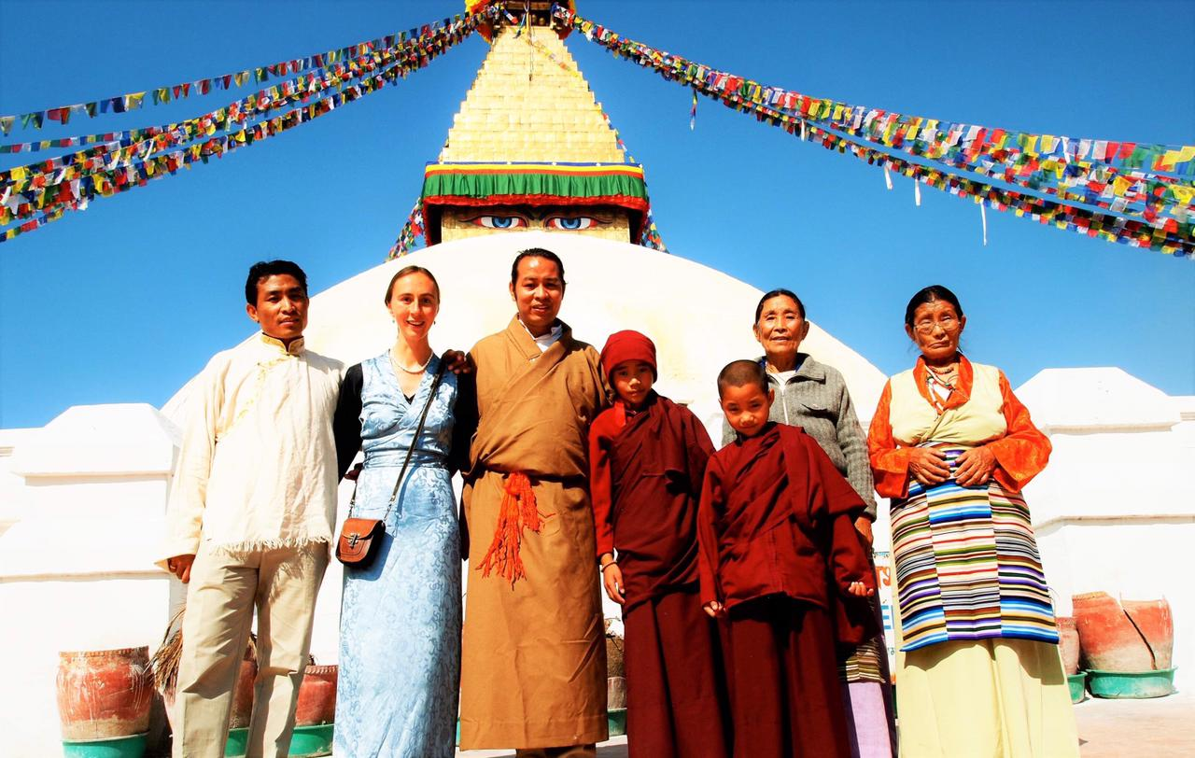

Another group of wonderful beings who substantially contributed to my Tibetan language learning was of course my བོད་པའི་ནང་མི།, my Tibetan family, including our dogs and cats. For about six years, I had the privilege to share their simple life, enjoy the delicious འཐེན་ཐུག (handmade soup) which my dear ཨ་ཅག་ལགས། (sister) made and join them to do སྐོར་ར། (circumambulations) at the great Bouddhanath stūpa every morning. I have learned so much from and with them including - but also way beyond - Tibetan language vocabulary. Their love and support will forever remain in my heart.

**His Holiness the XIV Dalai Lama**

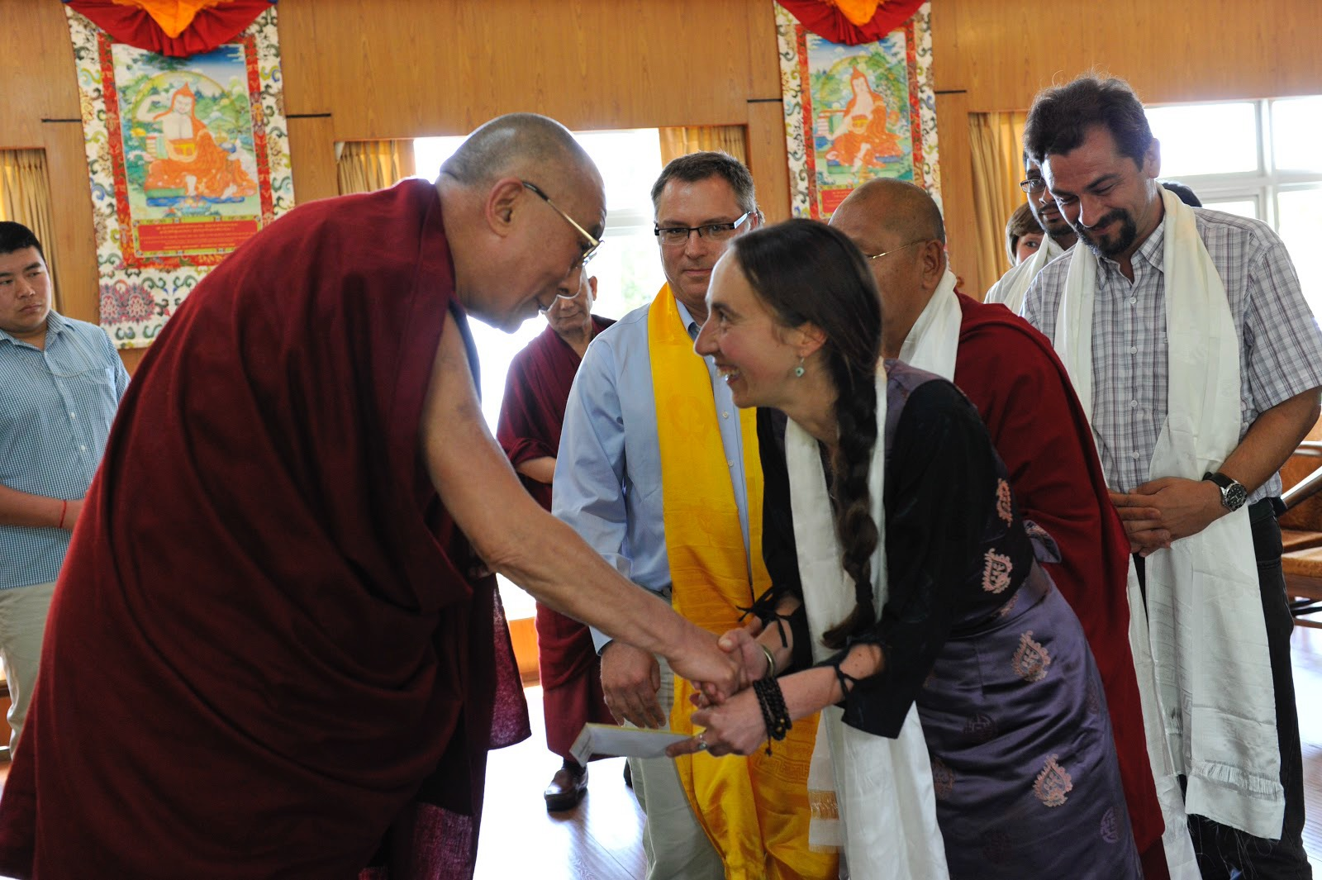

All the Tibetan language related studies and work I did over the past almost 20 years, is because of His Holiness the XIV Dalai Lama. I always like to say “It is all his fault.” :-) The dream of understanding his words in Tibetan directly set me out on this wonderful path. It’s an honour to be able to contribute a tiny bit to his wish to preserve the precious Tibetan language. His Holiness’ tireless and unwavering commitment to spreading the message of peace, compassion, human values, the promotion of the Tibetan culture and the Dharma as well as the care for the environment remain an unceasing source of inspiration.

His Holiness’ foreword of Volume 1 of my textbook is - no doubt - the best part of the textbook.

My gratitude for Geshe Lhakdor ལགས། from [LTWA](https://tibetanlibrary.org/) is also very deep.

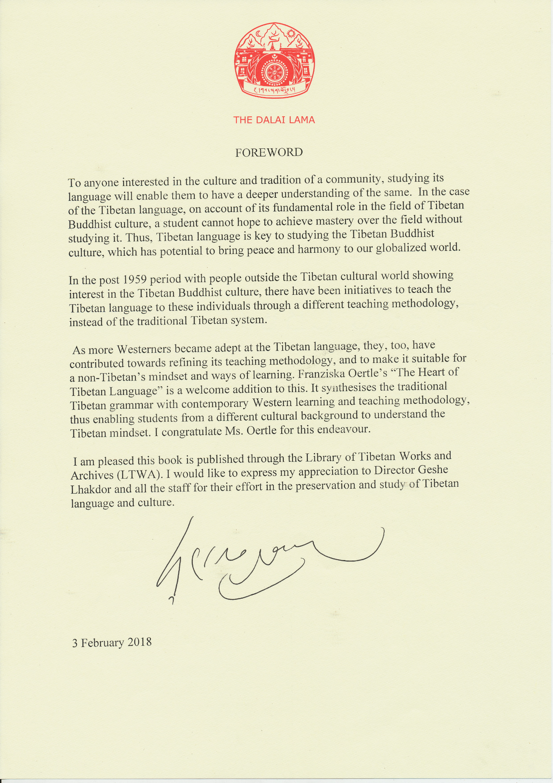

My favorite of His Holiness’ wisdom is:

“Be kind whenever possible. It’s always possible.”

And I believe that we need to include ourselves in that kindness too.

**Thích Nhất Hạnh**

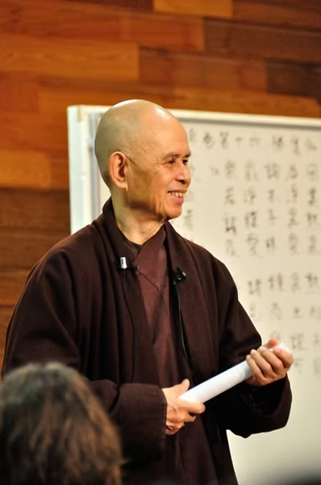

However, my interest in Buddhism was first sparked not through His Holiness the XIV Dalai Lama but by the teachings and practices of Zen master and peace activist Venerable Thích Nhất Hạnh.

His universal non-sectarian [Plum Village](https://plumvillage.org/) teachings and practices of peace and inclusiveness are guiding me day by day. I’m a lay-member of his Order of Interbeing and have been given the Dharma name True Earth of Wholesomeness. My favorite quote of Thây currently is: “Each moment is a chance for us to make peace with this world, to make peace possible for the world. The world needs our happiness.”

My mother and Mother Earth

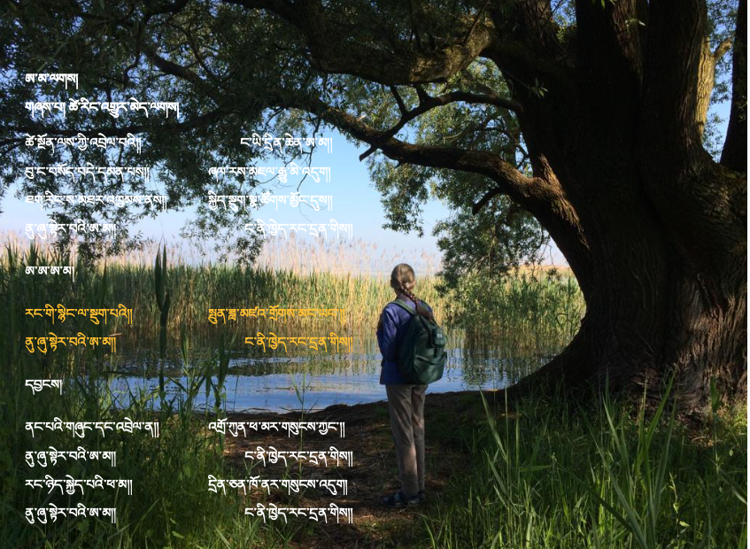

This website also would obviously not exist if it was not for my dear mother who brought me into this beautiful Mother Earth. But, not only that, she also supported and continues to support me on every step of my path and never questions my unconventional life-style of being a bit of a dreamer.

This leads me to the last and final quote by John Lennon: “A dream you dream alone is just a dream. A dream you dream together is a reality.”

Thank you for reading all of this.

And most importantly, thank you very much for studying the fascinating Tibetan language and thereby joining our dream of working towards its preservation.

ཐུགས་ཆེ་གནང་།

To conclude, please enjoy my favorite song [“Imagine”](https://youtu.be/bvFLKyAGzzI?si=evlJRDVCVFRSIv2V) by John Lennon. (embed this youtube video : <https://www.youtube.com/watch?si=evlJRDVCVFRSIv2V&v=bvFLKyAGzzI&feature=youtu.be>)